**Optimizing sales, Inventory management and analyzing shopping trends of a general store**

**A Final report for the BDM capstone Project**

Submitted by

Name: ATHARVA GARAJKAR

Roll number : 22f1000699



IITM Online BS Degree Program,

Indian Institute of Technology, Madras, Chennai Tamil Nadu, India, 600036

**Contents**

1. Executive Summary and Title 3
2. Detailed Explanation of Analysis Process 4
3. Results and Findings 6
4. Interpretation of Results and Recommendations 12

# Executive Summary and Title

The project, titled "***Optimizing Sales, Inventory management and Analyzing shopping Trends of Needs Corner General Store***," represents a comprehensive investigation into the operational dynamics and performance metrics of our general store. The project aims to extract valuable insights that can enhance sales, improve profit margins, and understand prevailing shopping trends.

The initiative began with a rigorous process of data collection and validation, ensuring the integrity and reliability of the data-set. Noteworthy findings include the identification of strategic sales peaks and the recognition of high-performing product categories.

Our analysis encompassed diverse statistical methodologies and user-friendly visualizations, presenting stakeholders with a comprehensive understanding of the general store's data landscape. The project emphasizes clarity and professionalism in conveying facts and ideas, with a primary focus on practical recommendations to drive operational excellence and strategic growth.

Key recommendations include targeted strategies to optimize sales and profit margins, with a specific emphasis on marketing collaborations with maximum customers, enhancing the in-store shopping experience, and tailoring product offerings to align with shopping trends. Furthermore, the project highlights the importance of adopting solutions to streamline the shopping process, personalized customer preferences according to seasons and many more.

In conclusion, the insights derived from the project provide Needs Corner with a road-map for making informed decisions, improving operational efficiency, and developing a growth strategy aligned with current market trends. The information serves as a valuable tool for optimizing sales, maximizing profit margins, and understanding and responding to evolving shopping behaviors in the retail sector.

# Detailed Explanation of Analysis Process

Embarking on an analytical journey at Needs Corner, our project was elaborately designed to unravel profound insights that go beyond mere data analysis. We went into the intricacies of optimizing sales, profit margins, and deciphering the complex shopping trends within the general retail landscape. The methodology adopted was a meticulous use of components, strategically aligned with the goals of our project.

* + The journey commenced with an exhaustive primary data collection process, placing a laser-focused emphasis on sales data. This phase was characterized by meticulous attention to detail, employing strict protocols.

Duplicate identification and correction of any missing or wrong entries were important to ensure the purity and accuracy of the data-set.

* + Understanding the affect of seasons was an important part of our study. We used special methods to break the data into three parts: Overall trends, seasonal patterns, residual components.

This in-depth analysis provided a complex understanding of temporary trends, offering insights into how seasons can influence purchasing patterns in a general store.

* + Our approach embraced diverse visualizations, ranging from pie charts to bar graphs and line charts, as channels for sharing important information.

Each visualization wasn't just a graphical representation but a interesting narrative, enabling stakeholders to intuitively grasp delicate shopping patterns and the interconnected dynamics within Needs Corner General Store.

* + The methodology was meticulously crafted to align with the comprehensive goals of optimizing sales, Inventory managements, and understanding shopping trends.

Exploratory Data Analysis (EDA) formed the bedrock of our knowledge base, supplemented by rigorous steps to replace missing values and ensure the consistency and reliability of the data source.

* + Beyond the realm of statistics, our analytical approach embraced the art of storytelling. The outcomes were not mere outputs; they were narratives waiting to be shared.

Our in-depth analysis yielded valuable conclusions, providing a rich source of information for optimizing sales,Inventory management, and analyzing the complex and delicate shopping trends.

## Recommendations:

Based on our meticulous review, we have put together some comprehensive recommendations for Needs Corner. These recommendations are to improve sales, Proper Inventory management and enhance the overall performance for sustainable long term growth in the respective sector.

## Report Clarity:

Our final report, carefully composed over several pages, stands as a beacon of clarity. Each component features well-crafted, informative titles seamlessly integrated with graphical support, contributing to a comprehensive puzzle. The techniques employed in our report aren't just tools; they are enablers of strategic decision-making, advancing a holistic understanding of the shopping landscape at Needs Corner General Store.

# Results and Findings

## Contribution of each category towards the Total store Revenue

Table including details of each category’s sale with respect to overall general store’s revenue

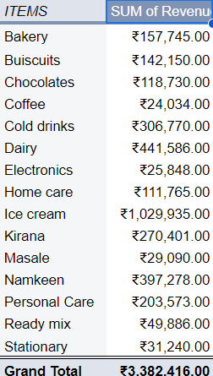

## Bar graph between Categories on X-axis and Revenue generated (in INR) on y-axis

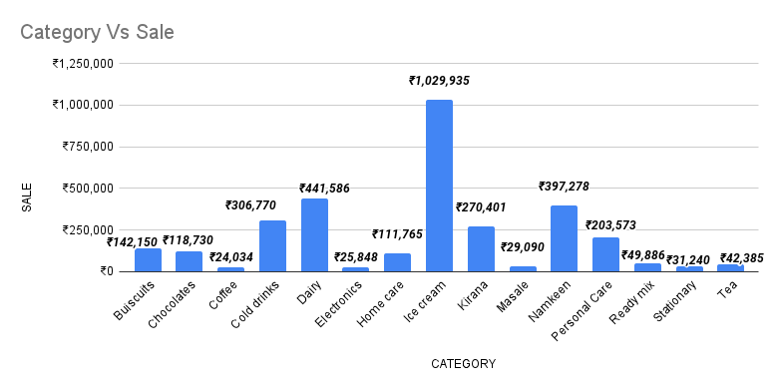

In our analysis of Needs Corner data, “Ice-cream” is the highest revenue generating category with Rs 10,29,935.00, which comprises 31.9% of overall revenue generated by the store. While “Dairy” and “Namkeen” are the next best sellers in terms of revenue generated, with revenue of Rs 4,41,586.00 and 3,97,278.00 comprising 13.7% and 12.3% of total revenue respectively, And following are the remaining categories with there respective total revenue generated and how much did they contribute to the Total Revenue. Cold-drinks with revenue of Rs. 3,06,770.00 contributing 9.5% of the total revenue, Kirana, Personal care, Buiscuits, Chocolates with revenue of Rs. 2,70,401.00, Rs. 2,03,573.00,Rs. 1,42,150.00, Rs. 1,42,150.00 and Rs. 1,42,150.00 contributing 8.4%, 6.3%, 4.4% and 3.7% of the total revenue respectively, While the combined revenue of Home-care, Ready-Mix, Masale, Electronics and Coffee came out to be Rs. 2,40,623.00 contributing 7.4% of the total revenue.

## Table including details of each category sales in percent with respect to overall revenue

|  |  |
| --- | --- |
| **Category name** | **Sale in %** |
| Ice cream | 31.9 |
| Dairy | 13.7 |
| Namkeen | 12.3 |
| Cold Drinks | 9.5 |
| Kirana | 8.4 |
| Personal Care | 6.3 |
| Buiscuits | 4.4 |
| Chocolates | 3.7 |
| Home care | 3.5 |
| Ready Mix | 1.5 |
| Masale | 0.9 |
| Electronics | 0.8 |
| Coffee | 0.7 |

## Pie chart on each category’s profit percentage share of store’s total profit percentage

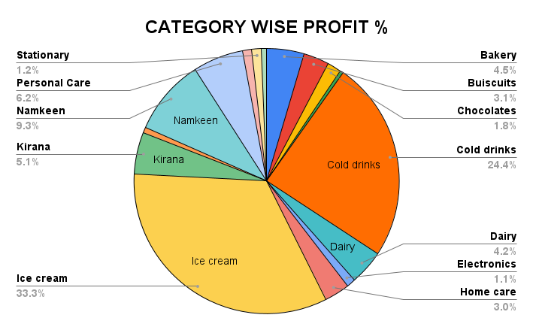

The pie chart illustrates the proportional distribution of profit percentage of sales across various categories at Needs Corner general store. Each slice represents a specific category, showcasing its share of the total sale profit percentage.

The pie chart reveals a clear distribution of sales among various categories at the store. “Ice-cream” as dominant category shares 33.33% of overall profit percentage, “cold-drinks” with 24.4% of profit percentage, “Namkeen” with 9.3% of profit percentage, “Personal Care” with 6.2% of profit percentage as well as “Kirana” also shares 5.1% and “Bakery”,”Dairy”, “Biscuits”,”Homecare”,”Chocolates”and “Stationary” with a combined profit percentage of 17.8%.

## Monthly wise Revenue Details

Table including details of month wise sales in INR in the store

|  |  |
| --- | --- |
| Month | Revenue |
| May | ₹822,734.00 |
| June | ₹1,071,484.00 |
| July | ₹797,629.00 |
| August | ₹690,569.00 |

## Total Revenue Vs Total Profit visualizing in a bar chart

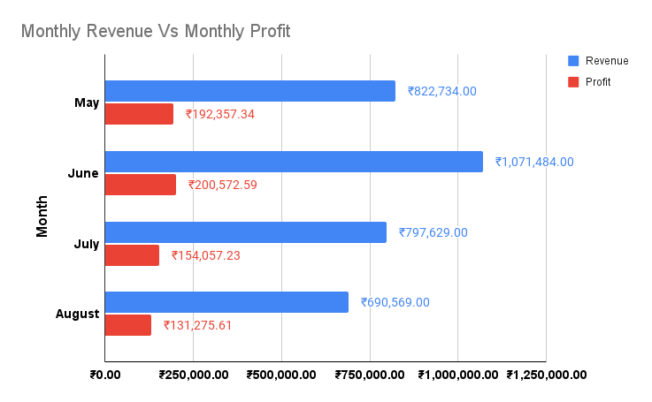

The above bar chart offers a visual representation of the fluctuation in total revenue and profit across a four-month span, explaining the store's monthly financial performance. Notably, the revenue figures for May, June, July and August stand at Rs. 8,22,734.00, Rs.

10,71,484.00, Rs. 7,97,629.00, and Rs. 6,90,569.00, respectively. Concurrently, the corresponding profit margins for these months reveal earnings of Rs.1,92,357.84, Rs. 2,00,572.59, Rs. 1,54,057.23 and Rs. 1,31,275.61. This data underscores a descent trajectory of growth, culminating in June’s pinnacle revenue, along with a little de- escalation in profitability. Such ups and downs in the store’s revenue and profit epitomize the store’s success throughout the time span

## V. Analysis of Sales over 4 month period (May-August, 2024)

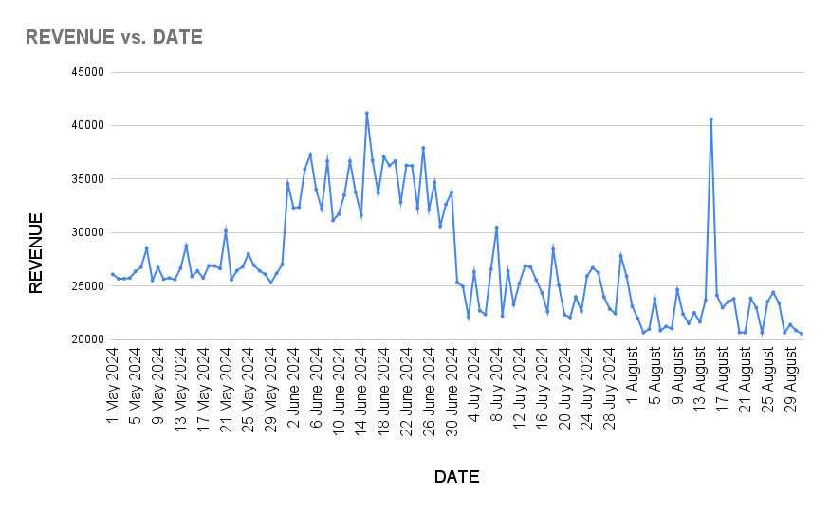

## Analysis of Revenue generated over 3 months period Vs Profit

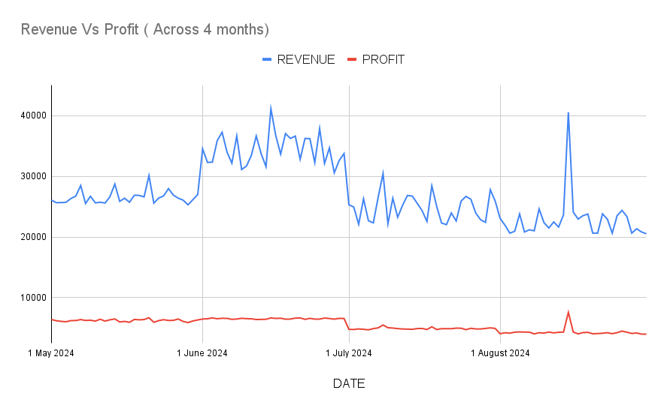

The line chart illustrates the revenue fluctuations of a local general store over the span of four months, providing valuable insights into its financial performance. Notably, a significant peak is observed at the commencement of June, marking a pivotal moment for future reference. This peak coincides with a notable surge in profit at that time of the month, indicating a period of heightened success for the establishment.

During this peak period, the general store achieved remarkable sales, with revenue reaching an impressive sum of ₹1,071,484.00 on its peak month. This surge in revenue also translated into the highest gross profit observed during that month period, showcasing the store's capacity to capitalize on increased demand effectively.

Subsequently, this surge in revenue has stimulated heightened customer engagement and increased demand for the general store’s offerings. This heightened engagement is indicative of the store's ability to attract and retain customers during peak periods, underscoring its relevance and appeal within the local community.

Moreover, the consistent flow of sales depicted in the chart underscores the general store's resilience and stability in generating revenue. Each month, the total revenue consistently surpasses 6.5 lakhs, reflecting a robust performance and suggesting a loyal customer base that contributes to the store's sustained success.

Furthermore, the chart serves as a valuable tool for identifying potential seasonal patterns, offering a complex understanding of customer behavior. This understanding is crucial for informed decision-making and sales optimization strategies throughout the year. By leveraging insights from the chart, the general store can proactively adjust its offerings, marketing strategies, and inventory management to capitalize on seasonal fluctuations and maximize profitability.

In essence, the line chart provides more than just a visual representation of revenue fluctuations; it serves as a strategic asset for the general store, empowering it to make data-driven decisions and adapt effectively to dynamic market conditions.

# Interpretation of Results and Recommendations

## Interpretation of Results:

Our extensive analysis of our general store has unearthed pivotal insights, offering a profound understanding of customer behavior and operational trends. This section is dedicated to explaining the significance of identified patterns and their implications on business growth, aiding the formulation of strategic plans.

* 1. Standout Performance of Key Products:

The analysis has identified certain products as standout performers within our general store.

By delving into the sales, pricing, and profit details of these key products, we can create in-depth case studies. Understanding the factors contributing to their exceptional performance will guide future inventory management and marketing strategies.

* + - Making profits using strategies for Key Products:
      * For the products which are standout performers, make them visible for everyone as there will be higher chances of buying them which gives us higher profit margins.
      * Also keeping in mind the consumer behavior we can even launch some good combo packs and offers on the items that generate larger amounts of profit.
      * The products which are slow moving can be put in a combo offer, which will make the shelf space as well as the items will be sold quicker.
  1. Seasonal Peaks and Operational Nuances:

Notable peaks in customer transactions during specific seasons prompt a focused exploration of operational nuances during those periods.

Particularly, understanding the factors driving increased activity in these seasons can be crucial for adapting our inventory, promotions, and staffing strategies accordingly.

* + - Possible reasons for this type of Peaks and consumer behavior:
      * Festivals might be the major causes for these types of peaks in sales allowing customers to buy more than usual. Also, month starting will be a peak time for sales as most of the people tend to buy their monthly personal care and home care items.
      * Maintaining the stocks is a challenge at this moment so, by observing the past sales trends in each category, make sure to have those items in the store for sure.
      * Due to natural causes like covid there might be a chance of inventory loss so, make sure to arrange your inventory in a safest place and offer items in a way that people can buy compared to all other stores in the locality.
      * Summers are always the most contributors towards the revenue as the most sold item Ice-cream is the main focus of the store.
      * As the store is located near schools, Sale is exceptionally high during 15 august and 26 Jan as students tend to celebrate those days with snacks, So make sure the stock of snacks are full.
  1. Responding to Changing Consumer Preferences:

The analysis sheds light on evolving consumer preferences, notably post-seasonal transitions. As we observe changes in demand for certain products based on weather conditions or seasonal shifts, we can tailor our product offerings, promotions, and marketing strategies to align with these changing preferences.

* + - Sudden changes in prices of items:

When we are aware of sudden changes in market prices make sure to sell more of the items

whose prices are going to change ( increase / decrease) drastically to avoid loss when it is not

in the demand.

## Conclusion and Future Strategy:

In conclusion, our in-depth examination of sales patterns and customer behaviors equips us with actionable insights for strategic decision-making. Leveraging standout products, understanding seasonal peaks, and adapting to changing preferences are key focal points for future strategy.

Our general store's success hinges on the agility with which we respond to these insights, ensuring a dynamic and customer-eccentric approach to operations and marketing. This report serves as a compass guiding us towards a future of enhanced performance, customer satisfaction, and sustained growth.

## Recommendations for Needs Corner General Store:

### Profit Maximization Techniques:

* 1. Dynamic Pricing Strategies:

Implement dynamic pricing based on demand, time of day, and seasonal trends. Leverage technology to adjust prices in real-time, optimizing margins while staying competitive.

* 1. Supplier Collaboration and Negotiation:

Strengthen partnerships with suppliers by fostering transparent communication.

Negotiate for volume discounts, promotional support, and favorable credit terms, thereby enhancing cost-effectiveness.

* 1. Product Bundling and Cross-Merchandising:

Explore opportunities for creating attractive product bundles and

cross-merchandising displays. Encourage customers to explore complementary items, boosting average transaction values.

* 1. Personalized Loyalty Programs:

Develop a personalized loyalty program that rewards customers based on their preferences and shopping behaviors. Tailored incentives can enhance customer loyalty and drive repeat business.

* 1. Smart Inventory Management:

Leverage advanced analytics to optimize inventory levels. Implement Just in

time inventory practices and conduct regular audits to prevent overstocking or stockouts, ensuring efficient stock turnover.

* 1. Eco-Friendly Initiatives:

Consider eco-friendly packaging options and practices. Many customers are willing to pay a premium for environmentally sustainable products, presenting an opportunity to both boost profits and meet sustainability goals.

* 1. Home Delivery:

Starting home delivery for nearby households if purchased above a certain value and certain items. Like delivering milk bags daily morning or personal care items at the start of the month.

* 1. In-Store Events:

Host in-store events such as cooking demonstrations or product tastings.

These can attract more customers and encourage them to try new products.

* 1. Online Presence:

Establish an online presence through a user-friendly website and active social media accounts. This can help attract a wider customer base and provide a platform for promotional activities.

* 1. Energy Efficiency:

Implement energy-efficient practices, such as using LED lighting or energy-saving appliances. This can significantly reduce utility costs over time.

* 1. Collaborating with schools:

Collaborating with school for the daily or monthly items like books, chalks, markers etc, while giving them a discount if buying from needs corner only and buying in bulk. Which will not only make students of these government school visit the store but also generate profit in the weaker sections such as stationary.

### Employee Retention Techniques:

* 1. Recognition and Rewards Programs:

Establish recognition programs that celebrate employee achievements and milestones. Rewards, both monetary and non-monetary, can significantly contribute to job satisfaction.

* 1. Flexible Scheduling Options:

Implement flexible scheduling options to accommodate diverse employee needs. This approach can enhance work-life balance and contribute to overall job satisfaction.

* 1. Employee Feedback Platforms:

Establish an efficient system for collecting employee feedback regularly. Act upon the feedback to address concerns promptly, fostering a culture of open communication.

* 1. Competitive Compensation:

Ensure your compensation packages are competitive for your area and industry. This can help attract and retain quality staff.

* 1. Positive Work Environment:

Foster a positive work environment where employees feel valued and respected. This can improve morale and productivity.

* 1. Regular Training:

Provide regular training to keep employees up-to-date with the latest industry trends and store policies. This can enhance their skills and confidence.

* 1. Team Building Activities:

Organize team building activities to strengthen relationships among employee and owner. This can improve teamwork and create a more enjoyable work atmosphere

## Customer Experience Enhancement:

* 1. Personalized Service:

Capitalize on the advantage by providing personalized service to customers.

Get to know regular customers by name, offer assistance with product recommendations, and tailor promotions to their preferences.

* 1. Local and Specialty Products:

Highlight locally sourced and specialty products that larger chains may not carry. Emphasize the unique offerings of the store, such as artisanal foods, homemade items, or products from local farmers and producers.

* 1. Community Engagement:

Foster a strong connection with the local community by participating in neighborhood events, supporting local charities or initiatives, and collaborating with nearby businesses to cross-promote each other's offerings.

* 1. Flexibility in Services:

Offer flexible services such as home delivery for elderly or disabled customers, personalized shopping assistance, or the option to place special orders for products not typically stocked in the store.

* 1. Customer Feedback:

Actively ask for feedback from customers through face-to-face interactions, suggestion boxes, or simple surveys. Use this feedback to make improvements and demonstrate to customers that their opinions are valued.

## Operational Efficiency Improvement:

* 1. Inventory Management:

Implement efficient inventory management practices suited to the store's size, such as regular stock checks, optimizing shelf space, and prioritizing fast-moving items. This ensures better control over stock levels and minimizes waste.

* 1. Cost-Effective Marketing:

Utilize cost-effective marketing tactics such as social media promotion, local advertising in community newsletters or newspapers, and word-of-mouth referrals from satisfied customers to attract new business.

* 1. Lean Staffing:

Maintain a lean staffing model by cross-training employees to handle multiple tasks, scheduling staff based on peak customer traffic times, and leveraging part-time or seasonal help during busier periods to minimize labor costs.

* 1. Technology Integration:

Embrace technology that aligns with the store's budget and needs, such as basic point-of-sale systems for efficient checkout, simple inventory management software, and email newsletters to communicate promotions to customers.

* 1. Supplier Relationships:

Cultivate strong relationships with suppliers, emphasizing the benefits of being a loyal customer despite the scale you buy. Negotiate favorable terms, discounts, or consignment arrangements where possible to optimize margins.

* 1. Continuous Improvement:

Encourage a culture of continuous improvement among staff by soliciting ideas for efficiency gains, cost-saving measures, and customer service enhancements. Empower employees to take ownership of their roles and contribute to the store's success.

## Overall recommendations :

## Implement these recommendations cohesively to strike a balance between profitability and customer satisfaction. Continuous monitoring and adaptation to market dynamics will be key to navigate the evolving landscape of the general sector. Cost optimization, employee satisfaction, e-commerce optimization, and customer-centric features are integral components for building a resilient and successful general store.